**Assignment 1**

**Question 1:** Frailty is physical weakness; lack of health or strength. Reduced grip strength in females correlated with higher frailty scores and vice versa. Hand grip strength can be quantified by measuring the amount of static force that the hand can squeeze around a dynamometer. The force has most commonly been measured in kilograms and pounds. The table below represents data from 10 female participants. The Height is measured in inches, Weight in pounds, Age in years, Grip strength in kilograms. Frailty is qualitative attribute indicated the presence or absence of the symptoms. Based on the following table, design the three stages of reproducible workflow, includes the work you can do and the folder structure in each stage (reference study case in chapter 3).  (5 points)

|  |  |  |  |  |
| --- | --- | --- | --- | --- |
| Height | Weight | Age | Grip strength | Frailty |
| 65.8 | 112 | 30 | 30 | N |
| 71.5 | 136 | 19 | 31 | N |
| 69.4 | 153 | 45 | 29 | N |
| 68.2 | 142 | 22 | 28 | Y |
| 67.8 | 144 | 29 | 24 | Y |
| 68.7 | 123 | 50 | 26 | N |
| 69.8 | 141 | 51 | 22 | Y |
| 70.1 | 136 | 23 | 20 | Y |
| 67.9 | 112 | 17 | 19 | N |
| 66.8 | 120 | 39 | 31 | N |

**Interpretation:**  
For the above data, I have checked for null values and outliers but didn’t find any need to update data as the observations are less. With the smaller number of observations I couldn’t really find any patterns or similarities. The change we could do is have frailty in binary instead of Y/N. I have two observations to visualize the frailty type with grip strength.

**Question 2:** Perform 5 data visualization tasks on the student performance dataset given in the link below (create 5 different visualizations). Explain what kind analysis has become easier with each of the visualizations. Create the folder structure for this question similar to question 1. (15 points).

Data link: <https://app.box.com/s/ji910ez3ycw137rw07xnhielxey7ww41>

Interpretation:  
For this Data set, I have performed 5 different visualizations

We could tell that more number females have opted to both free and standard meals more than the male students. This also conveys most students are opting to standard meal plan instead of the free meal plan.   
2. Math score vs gender,

We could tell from the plot the student average scores for both categories are almost similar. Also see that the more female students have lower scores which may have impacted there average.  
3. Race vs Parent education plan,

We could tell that Group C has the greatest number of students enrolled in Associate’s Degree and the overall least number of students enrolled in master’s degree is from Group A. It also tells us the group A has a smaller number of student enrolments overall and Group C being the highest.

4. Reading score vs test preparation plan

This could tell the average number of students who have opted for the test preparation plan is higher. Also conveys the students were rewarded with better scores if they choose to learn from the plan.   
5. Writing score vs gender  
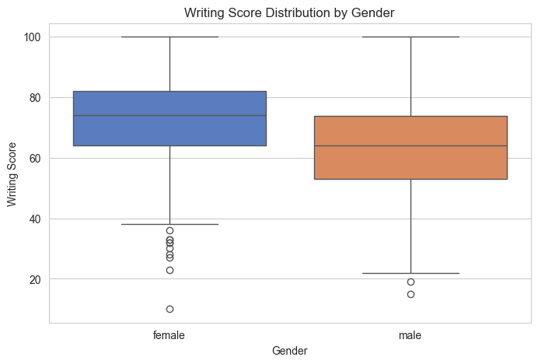

This also tells the average writing score is higher for the female students though having more observations with the least scores. In total the female students performed better in writing exam.